**Object-Oriented Programming**

**Vehicles**

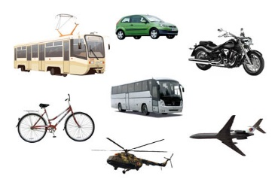

Design a program that can find a vehicle in a text file and create an appropriate object saving all information about this vehicle. There are many types of vehicles in the file: trucks, passenger cars, bikes, scooters etc. Each of them has own properties and it requires designing a class hierarchy.

*Prompt.* Separate the parts of code according to purpose. Use Java Code Convention.

*Use the knowledge from the previous assignment.*

**Extension of the task.**

Use in your program the next types of vehicles:

|  |  |
| --- | --- |
| **Vehicle** | **Fields** |
| Motorcycle | - color - body style - vehicle ID - engine capacity |
| Car | - vehicle ID - engine - mileage - model |
| Bus | - vehicle ID - engine - Fuel stock - Capacity |
| Airplane | - carrying capacity - id - max height - weight |
| Train | - vehicle ID - Length - Max speed - Type |
| Helicopter | - carrying capacity - id - max height - blades number |
| Aeroplan | - carrying capacity - id - max height - weight |
| Bicycle | - weight - model - maximum speed - type |
| Ship | - vehicle ID - weight - length - beam |
| Yacht | - vehicle ID - type - speed - length |
| Boat | - material - buoyancy - type - length |
| Barge | - type - capacity - weight - length |
| Air hot balloon | - carrying capacity - id - max height - duration |
| Spaceship | - vehicle ID - weight - fuel stock - length |
| Snowmobile | - speed - vehicle ID - mileage - model |
| Airship | - vehicle ID - length - volume - type |
| Scooter | - type - mileage - engine - vehicle ID |
| Metro | - engine - speed - length - vehicle ID |
| Quad bike | - speed - model - vehicle ID - engine |
| Van | - speed - engine - capacity - vehicle id |
| Hang-glider | - length - glide ratio - max speed - model |
| Submarine | - test depth - speed - engine - length |
| Segway | - distance per charge - charging time  - weight - max speed |
| Jet ski | - length - year built - person max - vehicle ID |
| Rocket pack | - endurance - gross weight - fuel stock - maximum speed |
| Tram | - length - engine - vehicle ID - type |
| Tank | - speed - weight - engine - crew |
| Jet Fighter | - weight - produced - vehicle ID - max speed |
| Catamaran | - weight - vehicle ID - speed - capacity |